

For women and children

(boys under 15 years old only)

Please join us for a lovely Holiday Celebration, on

**21st December 2017 at YMCA, Antelope Road,**

**Woolwich - SE18 5QL (From 11am to 2pm)**

There will be lots fun activities for children & Adults too, free lunch & free gifts for children.

**Please confirm attendance by calling Her Centre**

**020 3260 7715 or email navie@hercentre.org**



**Her Centre’s Holiday Celebration**

**Weekly One Stop Shop for women experiencing abuse**

Her Centre runs a weekly one-to-one drop-in offering practical, emotional and legal support to women affected by abuse.

The service is free and confidential with advisors from Her Centre, Housing 4 Women and solicitor Angela Simpson from Hudgell & Partners.

**Every Friday,10am to 12pm @YMCA Thames Gateway Antelope Road Woolwich, SE18 5PQ.**

Alternatively, please call us on **0203 260 7772** to make an appointment for advice

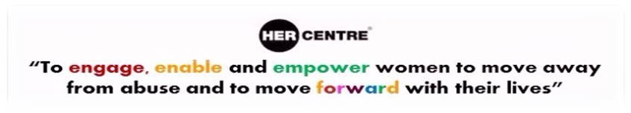

**About Her Centre**

Her Centre provides free and confidential advocacy, counselling, outreach, advice and training to women in Greenwich. For more information about Her Centre services, please visit our website at [www.hercentre.org](http://hercentre.org/) or call us on **0203 260 7715**.

**Free help with family law applications**

Our volunteering service offers clients free and confidential help and support with drafting court applications and statements especially in **Domestic Violence.**

The help concerns **Non-Molestation Orders** (to prevent one person and/or a child from being harmed or threatened by another), **Occupation Orders** (which decides who can live in the family home or enter the surrounding area) and **Divorce Petitions** (initial form filling only).

On occasion, where possible the volunteers can accompany clients to court.

**This is not legal advice, and disclaimers must be completed**

**For more information, please contact: Tel: 020 3260 7715 Email:** [**info@hercentre.org**](mailto:info@hercentre.org)

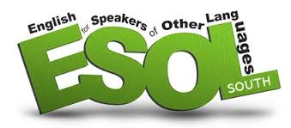

HER Centre offers free weekly English language classes for Non-English-speaking women. New session commenced on **Tuesday 7th November 2017 for 12 weeks**.

**These are now closed, but new classes will start in New year**

For more information and to register, contact  
Her Centre on: **0203 260 7715** or email **info@hercentre.org**

**Her Centre Women’s Group**

Would you like to meet other women in the community?

Would you like to learn new skills?

Would you like to share experiences and stories over a hot drink and a biscuit?

**Then come and join our drop-in women’s group!**

**Every Wednesday – From 17th January 2018**

**10am to 12pm**

At, YMCA, Antelope Road, Woolwich - SE18 5QL

**For more information and to register, please contact Vanessa Turney on:**

**Tel no: 020 3260 7772 / 07960 755 191**

**Email: vanessa@hercentre.org**

**Training and Information Day**

Her Centre is a service for women, the above training will be available for women only who are linked to the Greenwich borough.

**When:** Wednesday 28th February 2018;

10.30am - 12.30pm

**Where:** YMCA, Antelope Road, Woolwich - SE18 5QL

* ESOL classes

* Basic computer classes

* Child care and Health & Social Care courses

* First Aid training

* Administration

* Self-management courses

* Confidence Building & self-esteem courses

* CV writing & career confidence

**Please note that the above training will be available for women only**

For more information, please contact

Vanessa Turney on:

**Tel:** **020 3260 7772 / 07960 755 191**

**Email:** **vanessa@hercentre.org**

**Her Centre new Counselling Partner**

Her Centre are now working with the Deborah Ubee Trust, a specialist counselling service based in Greenwich, to run both one to one counselling and a weekly group. This allows us to offer women a few different counsellors, as different approaches can work for different people. We now have this service up and running, referring women who have used Her Centre’s IDSVA service and now feel ready for counselling.

Women are still encouraged to first attend the group therapy, run every Friday, as a way to get to know about therapy and build up an understanding of how it works. From there, women can then be referred to the one to one sessions.

Initial feedback from the women who have attended is very positive about the counselling, and once people find the building it is easy to get to.

The counselling is free for Her Centre clients, but for other women seeking counselling, Deborah Ubee do offer counselling on a sliding scale of fees, depending on your income. They also provide counselling for under 18-year olds, but there is a long waiting list for this free service.

**Women’s DV Awareness Training**

**When:** Every Wednesday - From 17th January 2018;

10am - 12pm (10 Weeks Course)

**Where:** 20 Egerton Drive, Greenwich - SE10 8JS

**Please note that the above training will be available for women only.**

This training is run by Deborah Ubee Trust, targeting women who don’t recognise abuse.

For more information, please contact us on:

**Tel: 020 3260 7715 / 020 3260 7772**

**Email: info@hercentre.org**

**Donations**

**Her Centre greatly appreciates donations to help us continue our work supporting women.**

**Donations can be made online at   
Virgin giving OR via JustTextGiving: simply text the code HERS11 plus £1, £2, £3, £4, £5 or £10**

**(e.g. HERS11£5) to 70070**

**Like us on Facebook:** <https://www.facebook.com/HerCentreGreenwich>

**Follow us on Twitter:** <https://twitter.com/hercentre>

**Visit our Website:** <http://www.hercentre.org>