#BeBoldForChange
Tell us about your bold moment!
Use this card to let us know about that exact moment when you took bold action to help improve or develop an aspect of your own life or that of another woman's, or women's status overall.
Hand this card back to us or email community-safety@royalgreenwich.gov.uk
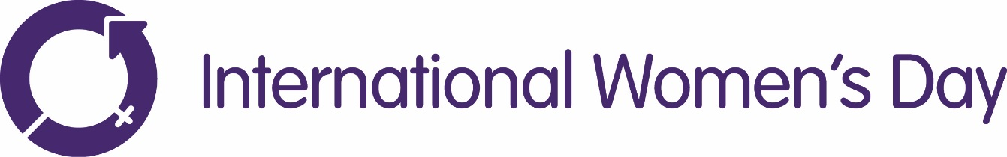
What was your bold moment?

How did you do it?

What motivated you?

What difference did you make?

How can others learn from this?

#BeBoldForChange

