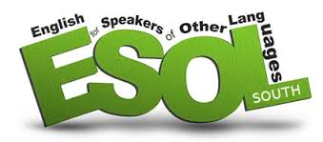

HER Centre offers free weekly English language classes for Non-English speaking women. New session commenced on **Tuesday 6th June 2017 for 12 weeks**.

For more information and to register, contact  
Her Centre on: **0203 260 7715** or email **info@hercentre.org**

**Consent and social media**

How are young people affected?

**Speaker:** **Her Centre, Met Police**

**Workshop by:** **Little Fish**

**Thursday 29th June 11am-2pm**

**Venue:** Town Hall wellington street, Woolwich SE18 6PW

RSVP to [***navie@hercentre.org***](mailto:navie@hercentre.org)or call **0203 260 7715**

**Weekly One Stop Shop for women experiencing abuse**

Her Centre runs a weekly one-to-one drop-in offering practical, emotional and legal support to women affected by abuse.

The service is free and confidential with advisors from Her Centre, Housing 4 Women and solicitor Angela Simpson from Hudgell & Partners.

**Every Friday,10am to 12pm @YMCA Thames Gateway Antelope Road Woolwich, SE18 5PQ.**

Alternatively, please call us on **0203 260 7772** to make an appointment for advice

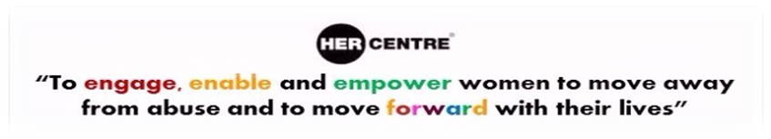

**About Her Centre**

Her Centre provides free and confidential advocacy, counselling, outreach, advice and training to women in Greenwich. For more information about Her Centre services, please visit our website at [www.hercentre.org](http://hercentre.org/) or call us on **0203 260 7715**.

**Free help with family law applications**

Our volunteering service offers clients free and confidential help and support with drafting court applications and statements especially in **Domestic Violence.**

The help concerns **Non-Molestation Orders** (to prevent one person and/or a child from being harmed or threatened by another), **Occupation Orders** (which decides who can live in the family home or enter the surrounding area) and **Divorce Petitions** (initial form filling only).

On occasion, where possible the volunteers can accompany clients to court.

**This is not legal advice, and disclaimers must be completed**

**For more information, please contact: Tel: 020 3260 7715 Email:** [***info@hercentre.org***](mailto:info@hercentre.org)



**HER CENTRE - 20TH ANNIVERSARY YEAR!!!!!!!**

Please join us to celebrate 20 years of working with women …. **14th Sept, Venue -Town Hall (From 5 to 8pm)**



**Interview with Her Centre Service User:**

* **How did you hear about the Her Centre and how did you find our service?**

“I was referred via Women’s trust. I find that the service I have received is brilliant and simply life changing”

* **Can you tell us about the support you received and how it has helped you?**

“The support I received saved my life. I came through the IDVA service, participated in group counsellingand I am also on the steering panel. Her Centre’s help has given me my voice back and has kept me away from abusive relationships.”

* **In your opinion is there any other support we could have given?**

“No not really because I have had after care and the support has continued even though I am no longer in an abusive relationship”.

* **Are you able to share with us the challenges that women in the same situation as you face?**

“Terrified, Isolated, very poor no support and before I came to Her Centre had no voice or power.”

* **Would you refer our services to other people who may need similar support?**

“Absolutely and whole heartedly I would.”

**Bexley DSV – Project**

(DSV - Domestic & Sexual Violence)

**“Tackling CSE- what we can do to stop it”**

(CSE – Child Sexual Exploitation)

**Wednesday 12 July 2017**

**Time: 2 - 5pm**

**Venue: Bexley Civic Centre**

**Her Centre are organising a day trip to……**

**Broadstairs Beach on**

**Monday 31st July 2017** - The Meeting point will be at

**9.00AM at the YMCA located at the Woolwich Dockyard Estate**

**For cost of the trip please contact The Her Centre on the number below**

**Please arrive promptly** – the coach will be leaving at 9.30AM andwill be returning at 4PM.

**Don’t forget to bring Sun Lotion, a Hat, Towel & Plenty of Water**

Here is to a wonderful day at the seaside!

**Prices** are on the consent form.

Please make sure to respond to the

**RSVP consent form,** to confirm your attendance.

**Contact Becky for more information if needed on**

**07538534981 or 02032607715**

**No Boys & No Men OVER 15 Years.**

**Donations**

**Her Centre greatly appreciates donations to help us continue our work supporting women.**

**Donations can be made online at   
Virgin giving OR via JustTextGiving: simply text the code HERS11 plus £1, £2, £3, £4, £5 or £10**

**(e.g. HERS11£5) to 70070**

**Like us on Facebook:** <https://www.facebook.com/HerCentreGreenwich>

**Follow us on Twitter:** <https://twitter.com/hercentre>

**Visit our Website:** <http://www.hercentre.org>