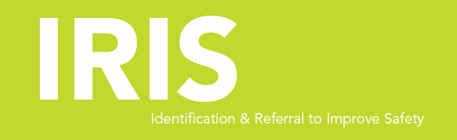

Female Advocate Educator,

IRIS (Identification & Referral to Improve Safety)

One post 35 hrs per week, Second post 17.5 hrs per week

NJC scale point 23 – 25 (equivalent to old NJC scale point 29 – 31)

Her Centre are looking for two experienced women domestic violence advocates who are highly motivated to liaise closely with general practices, provide training for clinicians and offer emotional and practical support to patients who are affected by domestic abuse.

The successful applicant will have:
- Experience of working with victims and survivors of domestic abuse
- Experience of promoting services and building strong working relationships with external organisations
- Experience of delivering training to a range of professionals
- An empathetic approach

Closing date: 3 August 2020 by 5pm

Interviews: 6/7 August 2020

IF YOU ARE INTERESTED IN APPLYING PLEASE CONTACT: reshma@hercentre.org

Her Centre is committed to Equal Opportunities. All posts are exempt under Section 7 (2) (f) of the Sex Discrimination Act 1975

