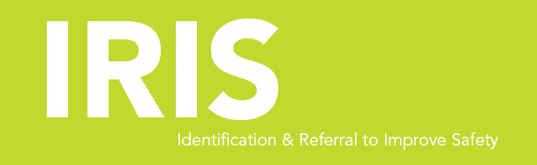

Female Advocate Educator,

IRIS (Identification & Referral to Improve Safety)

35 hrs per week

£28.811 including London Weighting

Her Centre are looking for an experienced female domestic violence advocate who is highly motivated to liaise closely with general practices, provide training for clinicians and offer emotional and practical support to patients who are affected by domestic abuse.

The successful applicant will have:
- Experience of working with victims and survivors of domestic abuse
- Experience of promoting services and building strong working relationships with external organisations
- Experience of delivering training to a range of professionals
- An empathetic approach

Closing date: 13 November 2020 by 5pm

Interviews: week commencing the 16th November

IF YOU ARE INTERESTED IN APPLYING PLEASE CONTACT: reshma@hercentre.org

Her Centre is committed to Equal Opportunities. All posts are exempt under Section 7 (2) (f) of the Sex Discrimination Act 1975

